Ideation Phase
Brainstorm & Idea Prioritization Template

Date | 17 February 2026
Team ID | LTVIP2026TMIDS66452
Project Name | ResolveNow: Your Platform for Online Complaints
Maximum Marks | 4 Marks

Brainstorm & Idea Prioritization Template:
In this phase, our team is encouraged to prioritize volume over value and welcome out-of-the-box ideas that lead to creative problem-solving. We aim to develop a system where users can easily submit complaints featuring multimedia attachments like images or videos to provide clear evidence of the issue. To enhance the "Now" in ResolveNow, we are looking at integrating Socket.io for instant status updates and a built-in messaging feature that allows direct interaction between the citizen and the assigned agent. On the backend, we are exploring automated routing algorithms to ensure every ticket is instantly sent to the correct department, alongside strict JWT-based authentication to maintain user confidentiality and secure the administrative dashboard.
Step-1: Team Gathering, Collaboration and Select the Problem Statement 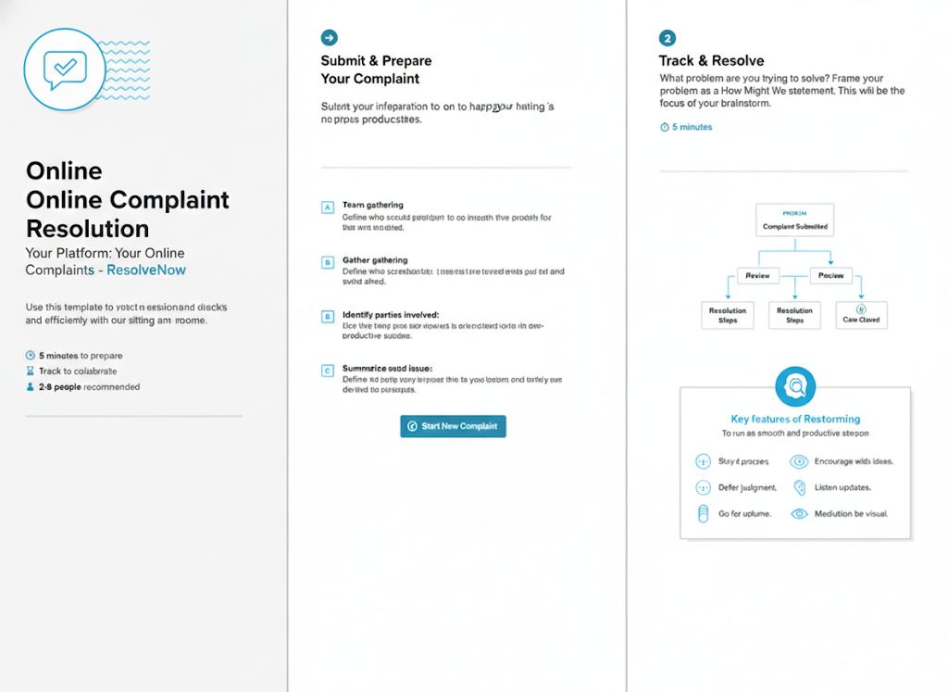

Step-2: Brainstorm, Idea Listing and Grouping
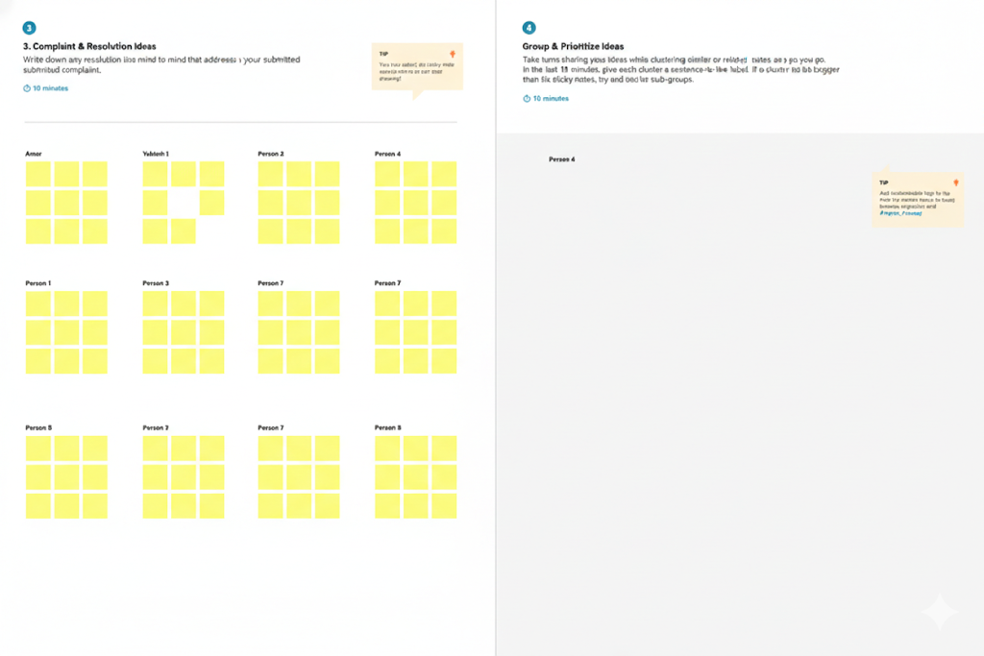

Step-3: Idea Prioritization
